|  |  |  |
| --- | --- | --- |
| **Attribute** | **Parameter value** |  |
| Product Catalogue | USB connector |  |
| Connector Types | Type-A |  |
| Standard | USB 2.0 |  |
| Male and female | Female |  |
| Number of contacts | 4 |  |
| Number of ports | 1 |  |

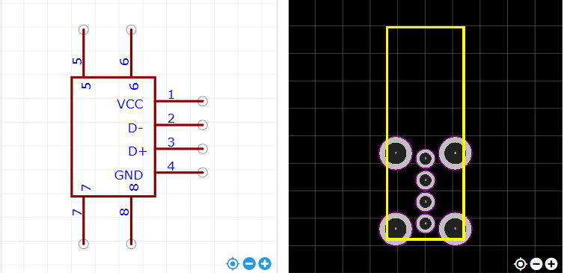

<https://item.szlcsc.com/26978.html>